RMIT ACCESSIBILITY DESIGN COMPETITION 2026
General Campus Guide - For RMIT & Non-RMIT Participants · Hackathon Days 1–3 (21–23 Sep)

New to RMIT SGS campus? Take a quick virtual look around: Welcome to RMIT Vietnam — Campus Tour

1. Campus Map & Check-in
All teams check in as a group, please gather with your teammates first, then check in together.
Location: check-in counter at the Canopy area, between Building 1 and Building 2.
Check-in hours
- Day 1: 7:30 – 9:00 AM
- Day 2: 8:00 – 9:00 AM
- Day 3: 12:00 – 1:30 PM
What you’ll receive at Check-in
- At Day 1 check-in, you will receive your name badge, lanyard, and ADC T-shirt for use throughout the 3-day event.
- A lunch voucher for Day 1 and Day 2 will be distributed during check-in. Please note that all lunch vouchers expire on 30 September 2026 and cannot be used after this date.
Please wear your ADC T-shirt on Days 1 and 3, and always keep your name badge and lanyard visible, as they are required for campus access.
Bring your ID every day
Please bring your Identity Card or passport to check-in every day. This applies to all participants, Vietnamese and international students alike. RMIT students may use their student card instead.
Arriving by motorbike
RMIT participants: park as usual, then gather with your team before heading to check-in.
Non-RMIT participants:
- At the front gate, tell the security officer you're attending an event (ADC Hackathon 2026)
- Park temporarily in front of Building 2 and go to the Building 2 entrance to complete check-in at the counter
- Once checked in, security will guide you to the internal motorbike parking zone
- Motorbike parking is available from 6:00 AM to 10:00 PM. The parking fee is 4,000 VND per day, which covers parking until 10:00 PM on the same day - cashless payment is available, or you're welcome to pay by cash if you prefer.
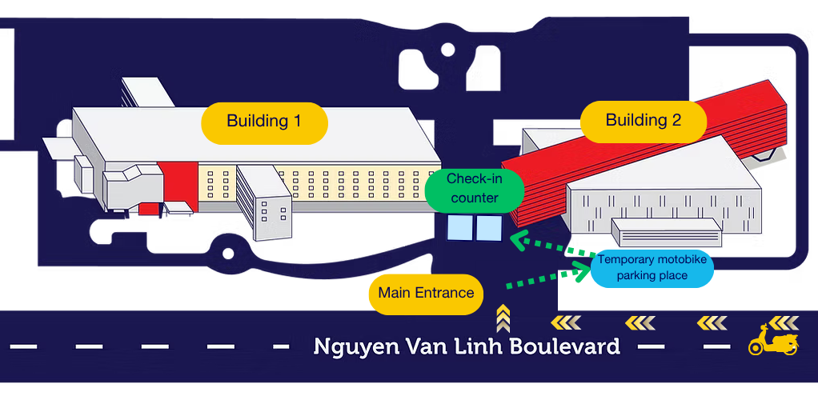

2. Wi-Fi on Campus
- If you have an RMIT student account and password, log into the university Wi-Fi as usual
- If not, connect to 'RMIT-Guest' Wi-Fi — open your browser and accept the terms and conditions to get online

3. Food & Drink on Campus
Your lunch voucher will be provided at check-in on Day 1 and Day 2. Enjoy complimentary drinks from Cheese Coffee on Day 1 and Boost Juice on Day 3. Water refill stations are available around campus, and we encourage you to bring your own tumbler to support our sustainability efforts. Please see the list of restaurants and food outlets around campus below.
*** Please note that lunch vouchers for Day 1 and Day 2 are only valid at selected restaurants. Kindly refer to the restaurant names printed on your voucher

Location | Outlets
Beanland Building / Building 1 (B1) | Juice & Coffee corners (L1) · Stationery shop - printing/photocopying (L1) · Lygon Café (L2 West) · Bobby Brewers (L5)
Food Court (Level 1), Building 1 | Noodle U · Global Café · Asian Corners · The Soya House · Vietcombank ATM
Food Pavilion | Highlands Coffee · The Curry Hut · La Cantina · 4Gs Texas Bakery
Academic Building 2 (AB2) | Boost Juice · Vending machine
Building 8 | Circle K convenience store (L1)
Building 9 | Nine Restaurant (L1)
Building 10 (REC-Recreation & Events Complex) | Sorrento Restaurant & Café (L2) · Vending machine (L1)

4. General Campus Opening Hours
Monday to Friday: 7:00 AM – 9:00 PM. Weekends: 7:00 AM – 6:00 PM.

5. Key Contacts & Emergency Info
Role | Contact
24/7 Campus Security Hotline (emergencies) | 1800 2233
On-Campus Medical Clinic (Mon–Sat, 8AM–6PM), Building 10 Ground Floor | (028) 3776 1360
After-Hours Medical Support (International SOS) | (028) 3999 8122
Event Hotline — Ms. Thanh Pham (urgent matters only) | (028) 3622 2492
ADC 2026 Zalo Group (for timely support) | zalo.me/g/hbrn6yjrfg6lr9xh0zlp

6. Other Campus Etiquette
- Consent for Media: capturing photos or filming campus community members requires their explicit verbal or written consent. More details here.
- Clean Spaces: please dispose of food waste and hackathon materials in the designated recycling and trash bins located around the buildings.

RMIT Accessibility Design Competition 2026 · ADC 2026 Organizing Committee

